Insert School Logo

Semester One Examination 2020
Question/Answer Booklet

MATHEMATICS SPECIALIST
UNIT 3

Section One:
Calculator-free

Student Name: _____________________________________
Teacher‘s Name: _____________________________________
Time allowed for this section
Reading time before commencing work: five minutes
Working time for paper: fifty minutes

Material required/recommended for this section

To be provided by the supervisor
This Question/Answer booklet
Formula Sheet

To be provided by the candidate
Standard items: pens(blue/black preferred), pencils(including coloured), sharpener, correction tape/fluid, erasers, ruler, highlighters

Special Items: nil

Important note to candidates
No other items may be taken into the examination room. It is your responsibility to ensure that you do not have any unauthorised notes or other items of a non-personal nature in the examination room. If you have any unauthorised material with you, hand it to the supervisor before reading any further.
Structure of this paper

 | Number of questions available | Number of questions to be attempted | Suggested working time (minutes) | Marks available | Weighting
Section One  Calculator—free | 7 | 7 | 50 minutes | 53 | 35%
Section Two  Calculator—assumed | 10 | 10 | 100 minutes | 97 | 65%
 |  |  |  | 150 | 100%

Instructions to candidates

- The rules for the conduct of Western Australian external examinations are detailed in the Year 12 Information Handbook 2020. Sitting this examination implies that you agree to abide by these rules.

- Answer the questions according to the following instructions.

Section One: Write answers in this Question/Answer Booklet. Answer all questions.

Show all your working clearly. Your working should be in sufficient detail to allow your
answers to be checked readily and for marks to be awarded for reasoning. Incorrect
answers given without supporting reasoning cannot be allocated any marks. For any
question or part question worth more than two marks, valid working or justification is
required to receive full marks. If you repeat an answer to any question, ensure that you
cancel the answer you do not wish to have marked.

It is recommended that you do not use pencil, except in diagrams.

- You must be careful to confine your responses to the specific questions asked and to follow any instructions that are specific to a particular question.

- Spare pages are included at the end of this booklet. They can be used for planning your responses and/or as additional space if required to continue an answer.
- Planning: If you use the spare pages for planning, indicate this clearly at the top of the
page.
- Continuing an answer: If you need to use the space to continue an answer, indicate in the original answer space where the answer is continued, i.e. give the page number. Fill in the number of the question that you are continuing to answer at the top of the page.

- The Formula Sheet is not handed in with your Question/Answer Booklet.

Section One: Calculator–free 53 marks

This section has seven (7) questions. Attempt all questions.
Write your answers in the spaces provided.

Working time: 50 minutes

Question 1 (7 marks)

Functions $f$ and $g$ are defined such that: $f\left(x\right)=\sqrt{4-x}$ $g\left(x\right)=\frac{2}{x - 2}$

(a) Determine $gf\left(x\right)$. (1 mark)

(b) Determine the domain and range for $gf\left(x\right)$. (4 marks)

(c) Given that $f^{-1}\left(x\right)=4-x^{2}$, is it true that $f^{-1}\left(-1\right)=3$? Explain. (2 marks)

Question 2 (9 marks)

The lines $L_{1}$ and $L_{2}$ have equations $r=\left(3+λ\right)i+\left(1+λ\right)j-2λk$ and $r=\left(a b c \right)+μ\left(4 -2 1 \right)$ respectively, with $a,b,c∈R$, and they lie on the same plane Π as shown.

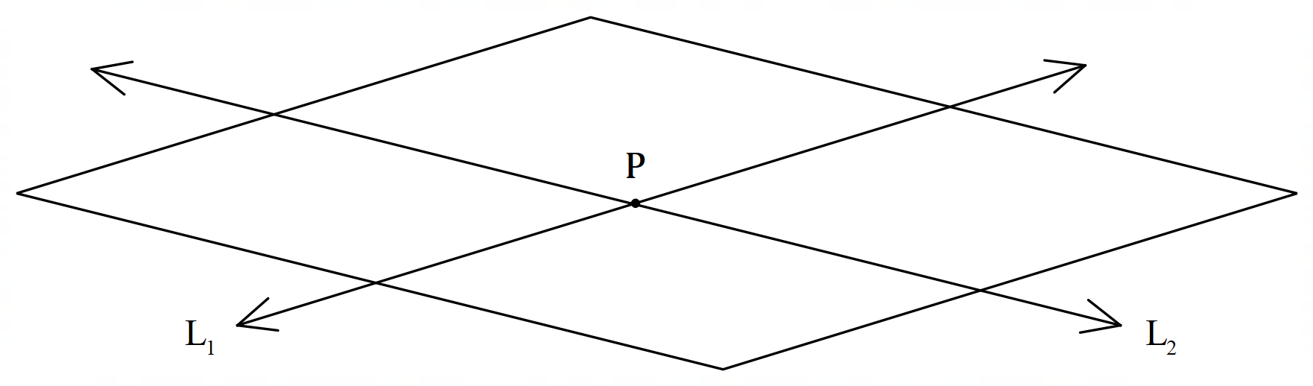

Π

(a) Given that the lines intersect at the point $P$ when $λ=3=μ+2$, determine the
value of the constants $a, b$ and $c$, and the exact distance of point $P$ from the origin.
(4 marks)

(Question 2 – Continued)

(b) A third line $L_{3}$ is perpendicular to the plane formed by $L_{1}$ and $L_{2}$, and passes through $P$.
Determine the vector equation of $L_{3}$ and the Cartesian equation of the plane Π.

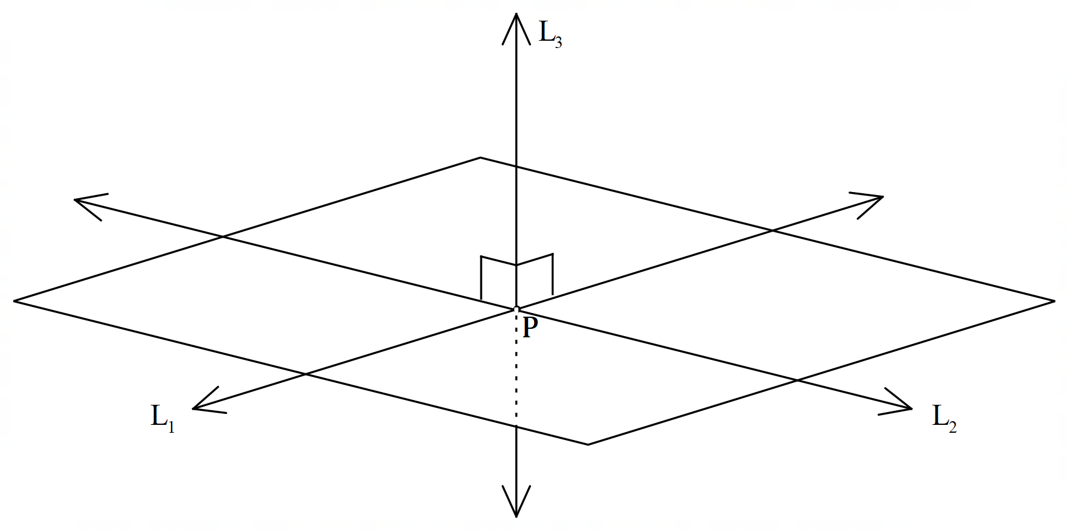

Π

(5 marks)

Question 3 (12 marks)

(a) Give an exact expression for each of the following in the form $a+bi$.

.

(i) (3 marks)

(ii) ${\left(\frac{1}{\sqrt{2}}-\frac{i}{\sqrt{2}}\right)}^{2020}$ (3 marks)

(Question 3 – Continued)

(b) Consider $f\left(z\right)=z^{3}-5z^{2}+8z-6$ where $z$ is a complex number.

(i) Show that $\left(z-1-i\right)$ is a factor of $f\left(z\right)$. (2 marks)

(ii) Solve the equation $z^{3}-5z^{2}+8z-6=0$. (4 marks)

Question 4 (9 marks)

The graph of $f\left(x\right)=2\sqrt{x+4}-2$ is shown below.

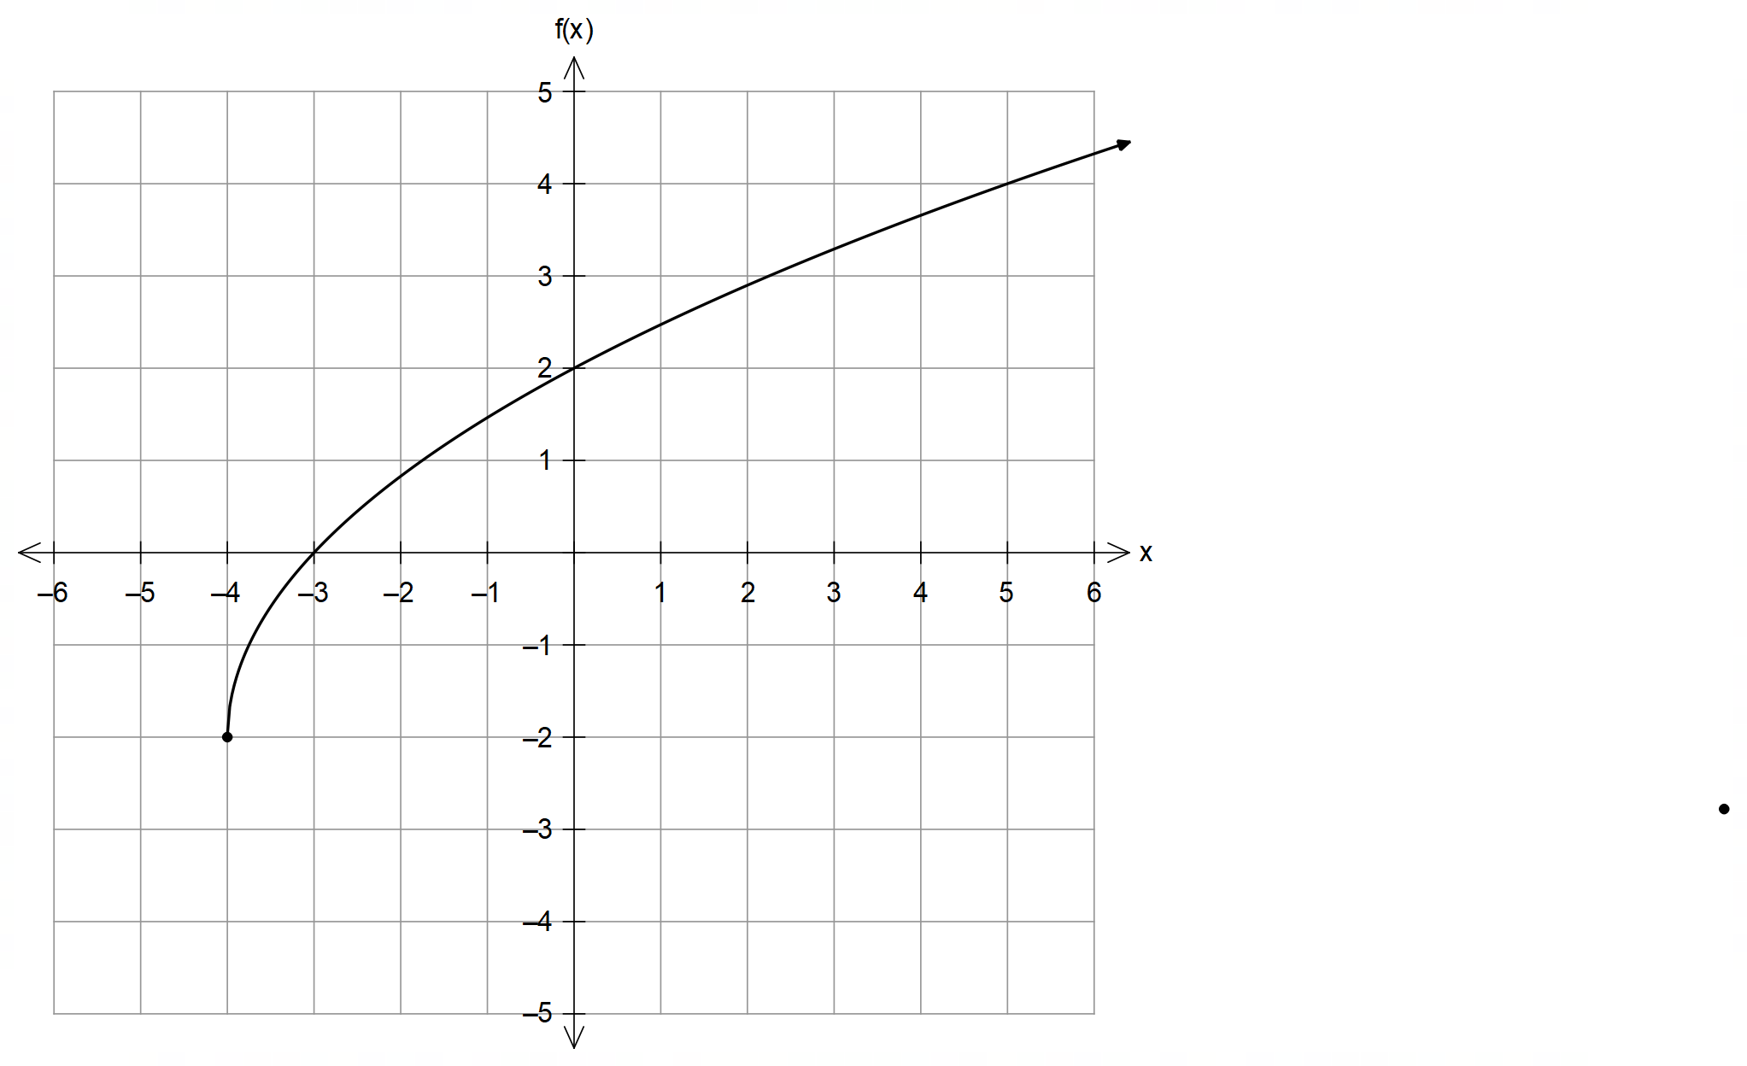

(a) Sketch the graph of $\frac{1}{f(x)}$ on the grid below. (3 marks)
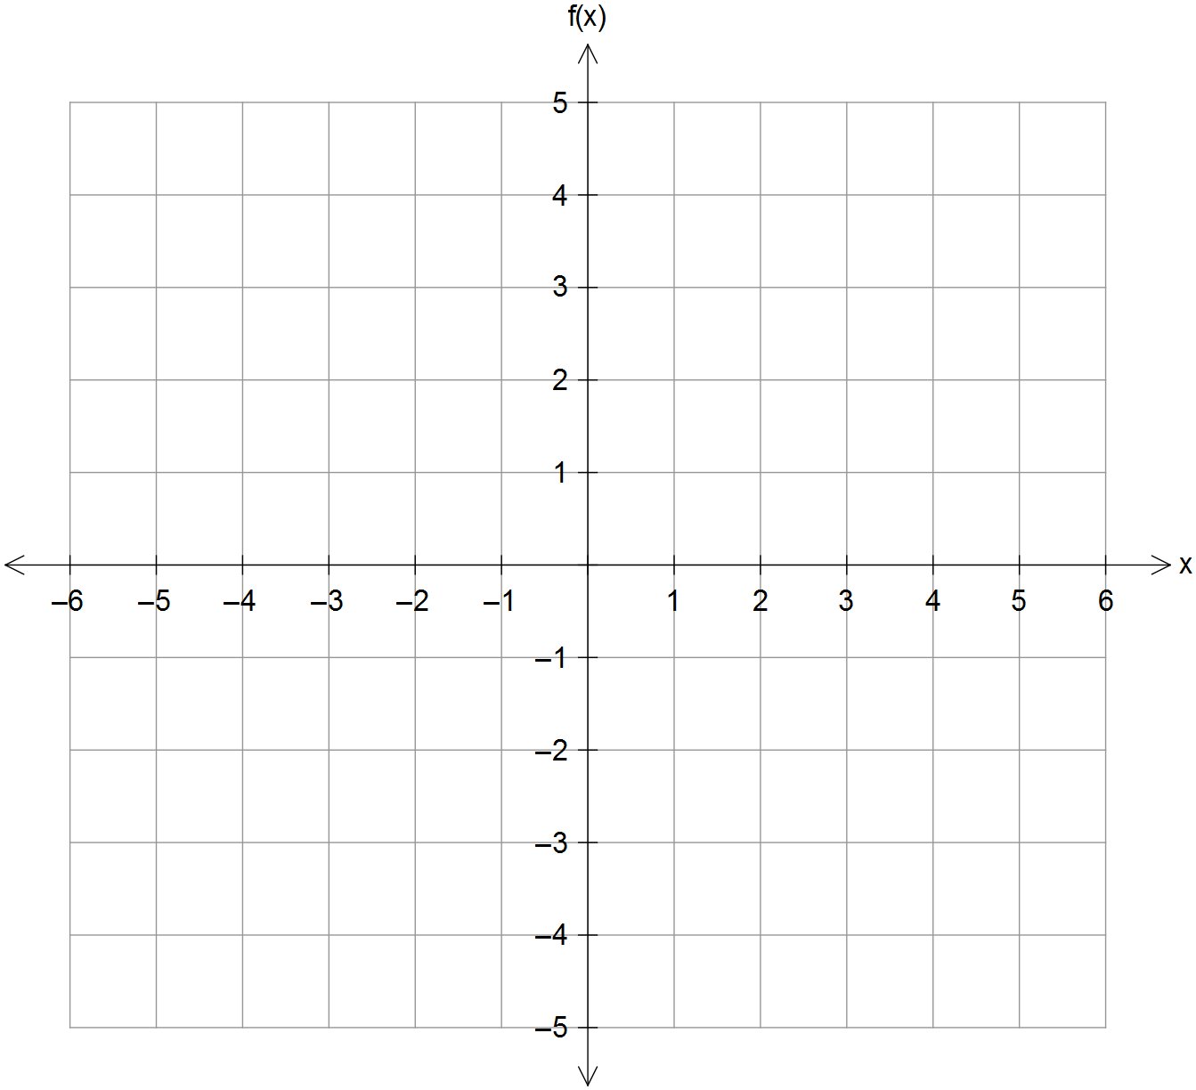

(Question 4 – Continued)

(b) Sketch the graph of $\left|f\left(-\left|x\right|\right)\right|$ on the grid below. (3 marks)


(c) The domain of $f\left(x\right)$ is restricted to $x≥k$ so that the inverse of$g\left(x\right)=\left|f\left(x\right)\right|$ exists.
Determine the value of $k$ and state the domain and range of $g^{-1}(x)$. (3 marks)

Question 5 (6 marks)

(a) Solve the system of linear equations below.
(3 marks)

$2x+y-3z+7=0 x+z-7=0 3y-z+7=0$

(Question 5 – Continued)

Consider another system of linear equations, where one of the coefficients is $k∈R$.

$x+y+z=0 2x+z=2 y+kz=-5$

It can be shown that the solutions to this system of equations are given in terms of $k$:

$x=\frac{2k + 3}{2k - 1}$ $y=\frac{5 - 2k}{2k - 1}$ $z=\frac{8}{1 - 2k}$

(b) Explain whether this system of equations will have a unique solution for all real values of $k$.
If not, then explain the geometric interpretation of this.
(3 marks)

Question 6 (6 marks)

The right rectangular prism ABCDEFGH shown is positioned in the Cartesian coordinate system such that AD is parallel to the x-axis, AB is parallel to the y-axis, and EA is parallel to the z-axis.

The vertices B and H have coordinates $\left(-2, 3, 4\right)$ and $\left(2, -5, -2\right)$ respectively.
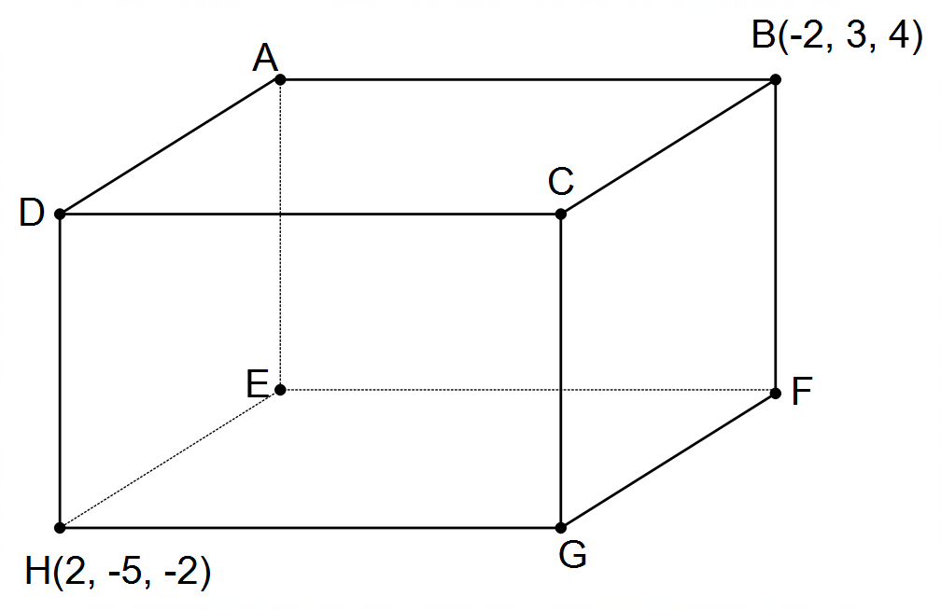

(a) State the coordinates of vertex E. (1 mark)

(b) Determine the percentage of the prism that lies in the first octant. (2 marks)

(Question 6 – Continued)

(c) Determine the vector equation of the sphere that has HB as its diameter. (3 marks)

Question 7 (4 marks)

Consider the set of complex numbers that is a solution to the equation $z^{n}=-1$, with $n∈N$.

Determine the value(s) of $n$ such that two of its solutions are $\left(\frac{π}{3}\right)$ and $π$.

Justify/explain your answer. (4 marks)

dditional working space
End of Section One

Question number(s): ……………………

Additional working space

Question number(s): ……………………

